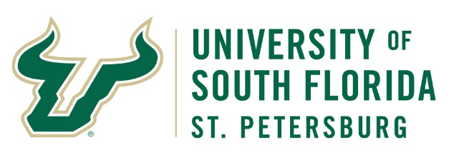
University Police Department
Alcohol Event Review
In order to facilitate a safe event for our University and community partners, the University Police Department (UPD) reviews all events that serve alcohol on campus. Please complete this form and it return it to the UPD Event Coordinator at STP-police@usf.edu.
Event Title: Enter text
Organization: Enter text
USFSP Coordinator: Enter text |  | Phone number: Enter text
On-site Contact: Enter text |  | Phone number: Enter text
Location: Enter text
Alternate/Rain Location: Enter text
Event Date: Click to enter a date | Expected Attendance: Enter text
Event Start Time: Enter text | Event End Time: Enter text
Will any of the following elements be present during the event:
☐Minors (under 18) will be in attendance
☐ Loud or live music
☐Safety or Risk Management Concerns: Enter text
Event Description:
Describe the event to include any speakers and the topic(s) of discussion. Provide a description of the bar setup and timeframe the beverage service will be available if the times vary from the overall event (i.e. cocktail hour). If guests will include persons under 21 years of age, please detail a plan for ensuring underage guests do not consume alcohol (i.e. checking IDs, wristbands, stanchioned areas, signs, etc.)

The use of alcoholic beverages at events held at the University of South Florida St. Petersburg are at all times subject to the applicable alcoholic beverages laws and ordinances of the State of Florida, the City of St. Petersburg and Pinellas County. Aramark Catering Services is the USFSP Dining Service provider. All other alcohol vendors must be approved by the Assistant Director of Event Services.

USFSP Coordinator’s Signature Date
PD109/June2021

UPD Use Only

Date Received: Click or tap here to enter text.

Reviewed By: Click or tap here to enter text. Date: Click or tap to enter a date.

☐Approved ☐Denied

Notes:
Click or tap here to enter text.

