STUDENT ACCESSIBILITY SERVICES

FACULTY RESOURCE GUIDE

Dear Faculty:

We invite you to use this Resource Guide to assist you in learning about your role in the accommodations process here at USFSP. Creating an accessible environment is a collaborative process that involves Student Accessibility Services (SAS), the faculty, and the students requesting accommodations. Please contact us should you need additional guidance, clarification, or if you have suggestions.

ABOUT THE SAS OFFICE:

Mission: Create and maintain an environment at the university that is supportive to students with various disabilities. SAS will grant academic accommodations to students with documented disabilities, providing them with equitable and accessible education.

Location and Hours:

Student Accessibility Services is located in the Student Life Center (SLC), Suite 1203.

Office Hours:

When classes are in session: Mon – Thurs. 8:30 to 6pm
Friday 8:30 to 5pm
When classes are not in session: Mon. – Fri. 8:30 to 5pm

Testing Hours: Testing may begin at 8:30 and end 30 minutes before closing.

DISABILITY LAW

It is the policy and practice of USFSP to comply fully with the requirements of the Americans with Disabilities Act of 1990, the ADA Amendments Act of 2009, and the Rehabilitation Act of 1973, all of which prohibit discrimination on the basis of disability. Students who have self-identified, provided documentation of a disability, and requested reasonable accommodations are entitled to receive approved modifications of programs, appropriate academic adjustments, or auxiliary aids that enable them to participate in and benefit from all educational programs and activities. The University’s ADA policy may be found at http://generalcounsel.usf.edu in the “Policies and Procedures” section.

A disability is defined as “any physical, learning, medical, or psychological condition that substantially limits a “major life activity.” Disabilities can be visible or non-visible. Disabilities covered by legislation include (but are not limited to) AIDS, blindness, cancer, cerebral palsy, diabetes, epilepsy, head injuries, hearing disabilities, specific learning disabilities, loss of limb(s), multiple sclerosis, muscular dystrophy, emotional disabilities, speech disabilities, spinal cord injuries, and vision disabilities.

STUDENT RESPONSIBILITIES

It is the student’s responsibility to identify him/herself to Student Accessibility Services and to provide documentation of a disability. All accommodations are approved on a case-by-case basis.

Once the documentation is reviewed by SAS, the student will attend an intake appointment with SAS to identify reasonable and effective accommodations. A Memorandum of Accommodations will be created which the student is responsible to present to instructors.

Students must request new Memorandums of Accommodations each semester. Students are not typically required to resubmit documentation every semester.

A sample Memorandum of Accommodations can be found in the addendum.

Students are encouraged to present the Memorandum of Accommodations (MOA) to instructors early in the semester; however, many students do attempt to complete course requirements without needing accommodations, thus, they may present the MOA later in the semester. Instructors cannot refuse to honor these accommodations; however, the student is responsible for providing sufficient notice for the accommodations to be arranged.

Students with disabilities must be able to maintain appropriate behavioral standards in class—the student conduct code applies to all students.

Students are expected to practice self-advocacy when classroom issues arise and to meet with instructors during office hours.

INSTRUCTOR RESPONSIBILITIES

It is the responsibility of faculty to work in conjunction with SAS to provide approved accommodations and support services, in a fair and timely manner, to students with disabilities.
Please note:
- Accommodations may be requested at any point in the semester.
- Accommodations are not retroactive.
- Certain accommodations may also apply in online courses (particularly with exams).
All faculty are encouraged to contact the office of Student Accessibility Services with suggestions, concerns or need for clarification about accommodations.

Syllabus Statement
SAS encourages instructors to include a statement in the syllabus informing students of the available services. For example:
“Students in need of academic accommodations for a disability may consult with Student Accessibility Services to arrange appropriate accommodations. Students are required to give reasonable notice prior to requesting an accommodation.”

Course Accessibility
Instructors are responsible for providing course information to students in accessible formats upon request and students are likewise responsible for requesting auxiliary aids/formats in a timely manner.

For students who are blind/low-vision, reserve front row seats. Videotapes, movies, and streaming video should be open or closed-captioned.
If the class is scheduled for a field trip, ensure that the site is accessible for students in wheelchairs or with other mobility issues. Also, transportation provided by the university must be accessible.

Note-taker
Students who have a disability that impacts their ability to take notes may utilize a copy of class notes provided by a fellow student who serves as a volunteer note-taker. If a student requests assistance locating a note-taker, please make the following announcement via Canvas and/or verbally in class:
“For reasons of a disability, a fellow student has requested assistance with note-taking. If you are willing to provide a copy of your notes, please contact Student Accessibility Services in SLC 1203.”

Please note that the student with a disability has the right to remain anonymous.
If the student wishes to remain anonymous to the note taker, SAS will arrange for the note-taker to either send or bring the notes to SAS and we will then forward them to the SAS student.
Exam Accommodations
Students receiving exam accommodations do not have to utilize SAS testing rooms. If, however, the student or the instructor prefers to use SAS, the procedure explained below will apply. It is important for the Test Assistance Request form to be delivered to SAS well in advance so that the office can plan accordingly. It is also critical for the section of the form which asks the instructor to state allowable materials be completed thoroughly.

A sample of the Test Assistance Request form can be found in the addendum.

Based on the documentation submitted to SAS, extended time is typically approved in increments of either 1½ or double the allotted class time. Extended time does apply to all online exams. Extended time does not apply to take home exams.

In some cases, the student who receives extended time will have another class that interferes with this accommodation; therefore, the exam will need to be scheduled at a time that is conducive to this accommodation. Exams in evening classes will also need to be scheduled during SAS office hours (unless the instructor can provide the accommodation during class time).

Exam Scheduling: If the student desires to use SAS for testing, it is his/her responsibility to comply with all scheduling procedures and policies.
- The student first should schedule the exam appointment in SAS at least 5-7 days before the exam.
- After scheduling, the student and the instructor complete the Test Assistance Request form and the student returns it to SAS at least 3 days before the exam. If the student needs to reschedule the exam for any reason, he/she must obtain the approval of the instructor.

Final Exam Scheduling: Due to the large numbers of exams needing proctoring, students are instructed to schedule their Final Exams three weeks prior to the end of the semester to enable SAS to obtain proctors and rooms. Should the number of exams exceed the availability of testing spaces, an alternative testing time may need to be arranged.

Exam security and delivery to SAS: SAS is highly sensitive to the need for exam security. Exams electronically sent should be emailed to usfsp-sas-exams@usf.edu. Exams are secured in a cabinet with multiple security devices. Exam testing rooms in SAS are monitored by cameras.
In order for exams to begin promptly at the appointed time, it is advisable for exams that are electronically delivered to SAS and requiring printing, sorting, etc. be emailed to SAS at least one hour prior to the scheduled start time for staff to complete the necessary tasks.

Extended Time on Exams in Canvas:
For students taking timed online exams away from the classroom, the instructor can provide extended time for the individual student by following this process:
- Click “Quizzes” on the left course menu.
- Click on the name of the exam you want to update.
- Click “Moderate this Quiz” on the right side of the screen.
- Click the checkbox next to the student’s name.
- Click the button “Change extensions for [1] selected students.”
- Type the extra amount of minutes in the “Extra time on every attempt” field.

Please note that quiz availability dates still apply when moderating a quiz. If the ‘Until date’ (availability end date/time) passes when the students are taking the quiz with extended time, the quiz auto-submits even if the student’s time extension has not expired. For this reason, you would want to provide students with time accommodations with their own availability dates/times so those accommodations can function as intended.

For additional help, please contact USF IT for Canvas support at: (813) 974-HELP (4357)

FREQUENTLY ASKED QUESTIONS

What should a faculty member do if they suspect a student has a disability?
- In private, the faculty member should ask the student how he/she can be supported.
It is best to focus on the difficulties and recommend the various support services and departments on campus, including SAS. It is not appropriate to directly ask or suggest that the student has a disability.

What if a student requests an accommodation without a letter from SAS?
- Instructors should refer the student to SAS. Unless the student is registered with SAS, any academic modification is not considered an ADA accommodation - it is a courtesy offered by the instructor.

Does the “extended time” accommodation apply to homework and other assignments?
- If a student is approved for extended time, this applies only to exams, quizzes, or assignments to be completed in class or as a timed online exam.

What are some other common classroom accommodations?
- Recording lectures
- Preferential seating
- Ability to leave class periodically
- Use of a laptop for taking notes
- Use of a computer for essay exams

RESOURCES

Universal Design of Instruction: “The goal of UDI is to maximize the learning of students with a wide range of characteristics by applying Universal Design principles to all aspects of instruction (e.g. delivery methods, physical spaces, information resources, technology, personal interactions, assessments.” Sheryl Burgstahler, PhD, U. of Washington DO-IT

For a complete UDI application checklist, consult Equal Access: Universal Design of Instruction at: https://www.washington.edu/doit/equal-access-universal-design-instruction

Etiquette for Working with Students with Disabilities:

For guidelines for engaging and interacting with people with disabilities in a courteous, thoughtful manner and for tips for working with specific disabilities, please consult this link:
www.bestcolleges.com/resources/disability-etiquette.

Other Resources:

Commonly Utilized Accommodations:
http://equity.psu.edu/student-disability-resources/faculty-handbook/common-accom

Accommodations for Students with Psychiatric Disabilities:
http://www.washington.edu/doit/psychiatric-impairments

Accommodations for Students with Learning Disabilities:
http://www.washington.edu/doit/learning-disabilities

Tools for Promoting Disability Access and Inclusion
https://exploreaccess.org/

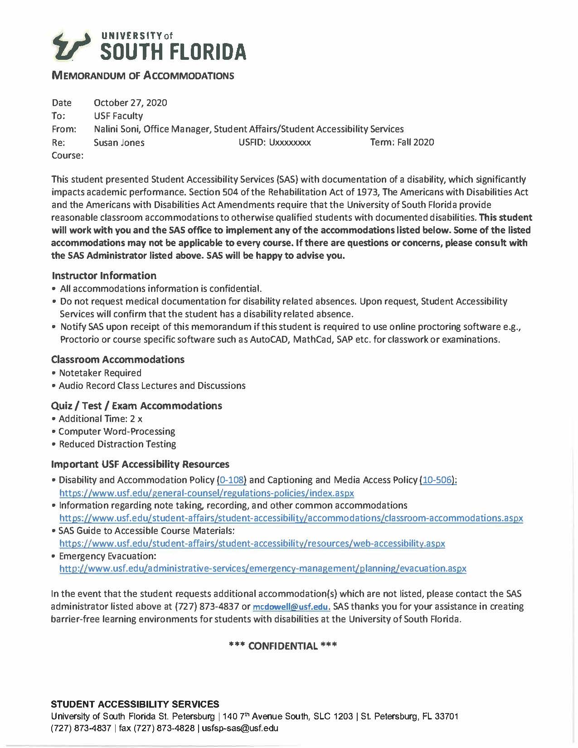

STUDENT ACCESSIBILITY SERVICES
TEST ASSISTANCE REQUEST FORM

It is the student’s responsibility to turn in the form at least one (1) week prior to the scheduled test date.
Failure to do so may result in our inability to schedule the requested accommodations. If instructions remain the same for each test, students and instructors can complete one form for each course for the entire semester.

PART I TO BE COMPLETED BY THE STUDENT:

Student’s Name: __________________________________________________________________
E-mail: ______________________________________ Phone #: __________________________
Course # & Name: _________________________________________________________________
Test Date: ____________________________________ Start Time: _________________________
Test Date: ____________________________________ Start Time: _________________________
Test Date: ____________________________________ Start Time: _________________________
Test Date: ____________________________________ Start Time: _________________________
Test Date: ____________________________________ Start Time: _________________________
INSTRUCTOR’S APPROVAL REQUIRED if date or start time is different from class time. Instructor please sign or initial here:________________________________________

PART II TO BE COMPLETED BY THE INSTRUCTOR:

Please plan on sending the tests in advance. If possible, at least two days prior to test date. Thank you.

Instructor’s Name: ____________________________________________________________________
E-Mail: __________________________________________ Phone #: _________________________
Student responses on Scantron: Yes ______ No ______ Proctor for test: Yes _______ No_______
Regular class time allowed (do not include this student's time accommodation): ___________________
Instructions and/or test materials permitted:
Calculator _________________ Scratch Paper _______________ Periodic Table ______________
Formula Sheet ______________ Other ____________________________________________________

Test Delivery: Please indicate one:
Instructor will deliver test to SAS (SLC 1203) __ OR email: usfsp-sas-exams@usf.edu (faculty only)__

Test Return: Please indicate one:
Instructor will pick-up test from SAS __ OR SAS will return the test within 24 hours to: ____________
office location

SAS PROCEDURE FOR TESTING ACCOMMODATIONS

- The student schedules quizzes and/or exams with SAS (preferably during the first 3 weeks of the semester).

- The student and instructor complete the Test Assistance Request Form. The form may be picked up in the SAS office in SLC 1203 or it can be printed from our website: https://www.stpetersburg.usf.edu/student-life/resources/student-accessibility-services/
The student should first fill out PART I of the form and then ask the instructor to complete PART II. Please complete the form in pen.

- The completed form should be received by SAS prior to the scheduled exam (preferably 3-5 days prior) so that testing space and proctoring can be arranged.

GUIDELINES AND POLICIES FOR TAKING EXAMS IN SAS

Late arrival If you arrive more than 15 minutes after your scheduled examination time, you may have to reschedule your examination with your professor. Scheduled exam times will not be extended to allow for late arrival.
Illness If you are unable to take an examination due to illness or emergency, contact your instructor immediately and make appropriate arrangements. It is your responsibility to reschedule examinations or to request adjustments to testing times.
Canceling examinations You must contact SAS in advance to cancel any scheduled examination. Failure to contact SAS may result in the inability to access testing space in the future. If you drop a course, contact SAS.
Breaks during examinations Students will not be allowed to take restroom breaks unless it has been approved as a medical accommodation. An approved break is considered part of your overall testing time, no additional time will be added.
Examination completion You will not be able to access your examination once you turn the exam into an SAS proctor or if you leave the test center without consent.
Academic dishonesty Instances of academic dishonesty including but not limited to: cheating, plagiarism, using materials and equipment not previously approved during the exam or bringing items not previously approved by SAS testing staff into the testing room will result in your inability to continue utilizing SAS testing space. In addition, SAS will notify the academic faculty of the alleged violation for appropriate sanctions under the academic integrity policy.
Items Not Allowed in the Testing Room
- Cell phones, purses, book bags
- Food - only if indicated as permitted on Accommodation Letter
- Electronic Devices - only if permitted by the instructor on Test Assistance Request form
- Sunglasses and hats/ball caps – only if indicated as permitted on Accommodation Letter
Student Accessibility Services
USF St Petersburg campus Student Life Center 1203
Phone: (727) 873-4837 Fax: (727) 873-4828 email: usfsp-sas@usf.edu

Barry McDowell, Assistant Director (727) 873-4990 mcdowell@usf.edu
Nalini Soni, Office Manager (727) 873-4837 nsoni2@usf.edu

